KUTUMBA
Families Growing in Krishna Consciousness

PRASĀDA, HOSPITALITY AND WEEKLY OPERATIONS
Complete Operating Manual, Recipe System and Implementation Toolkit
Founding pilot: five to six families | 20–25 participants | Friday evenings
Version 1.0 • June 2026 • Controlled reference draft for local approval

Document Control
  - Authority, use and approval status
Field | Controlled value
Document owner | KUTUMBA Operations and Prasāda Lead
Supporting owner | Documentation and Calendar Lead
Safety authority | Children and Safety Lead may stop any unsafe activity
Worship authority | Kīrtana and Worship Lead; exact procedures require qualified ISKCON/local approval
Operational scope | Five to six families; approximately 20–25 people; private Friday-evening cohort
Review cadence | After every six active weeks; formal annual review
Current status | Implementation-ready framework; venue, legal, allergy and worship approvals remain local launch gates
Source priority | Applicable law and venue rules → qualified worship authority → participant medical plan → this manual → personal preference

Important limitation This manual is an operating framework, not legal, medical or pūjārī authorization. A local venue or regulator can impose stricter requirements. Exact offering procedures are intentionally separated from the food-safety workflow.

How to use this manual
Read Parts I–II before assigning families. Train from Parts III–IV. Operate each Friday with the appendices. Treat the checklists and forms as controlled documents, not optional suggestions.
• Core rule: the simplest reliable system is the correct system.
• Operational test: can a trained backup run the week without the founder?
• Safety test: can leaders state exactly who may stop service and why?
• Devotional test: does the system support a clean offering and respectful honoring of prasāda without turning food into competition?

Contents at a glance
Division | Title | What it controls
Part I | Foundation and governance | Purpose, principles, assumptions, decision rights
Part II | Service rotation and people system | Six-family roster, five-family fallback, training and competency
Part III | Prasāda production system | Menus, quantities, recipes, ingredients, allergies and illness controls
Part IV | Friday operations | Weekly cadence, transport, offering boundary, holding, serving, children, cleanup
Part V | Assets, finance and assurance | Equipment, storage, inventory, costs, records, incidents and improvement
Appendices | Implementation toolkit | Roster sheets, forms, logs, labels, checklists, recipes and references

Executive decision summary
Recommended launch model Six stations, six-week rotation, four demonstration weeks, four shadow weeks, eight stable menus, two emergency menus, Tuesday confirmation, Wednesday headcount lock, Thursday quantity lock and a six-cycle review.

Decision | Standard
Meal structure | Three principal preparations; one optional fruit or festival sweet only when scheduled
Menu range | Eight recurring menus rather than forty unique menus
Food-safety targets | Hot ≥140°F; cold ≤40°F; legal/model-code minimums still verified locally
Allergy stance | Never promise allergen-free food from multiple home kitchens
Funding | No pooled money for the first six months; track actual costs privately
Children | Family seating during pilot; adult-only hot-equipment zone
Failure posture | Simplify, substitute or omit the meal rather than improvise unsafe food
Stop authority | Operations: food; Worship: offering; Safety: child/allergy

PART I
Foundation and Governance
A devotional meal requires both loving intention and controlled execution.

1. Purpose, scope and operating assumptions
KUTUMBA’s prasāda system exists to support the Friday program, not dominate it. Its purpose is to make clean, appropriately offered, safely handled and hospitably served food available through a sustainable family-service rotation.

1.1 Scope
• Five to six participating families, normally 20–25 people including children.
• Friday gatherings with a formal close around 9:00 p.m.
• Food prepared primarily in participating family kitchens and transported to the venue.
• One primary cook family, one operations backup family and distributed non-cooking roles.
• Private cohort operations. Any public sale, open public event, fundraiser or major scale-up requires a separate regulatory and risk review.

1.2 Key assumptions
Assumption | Launch implication
The venue permits outside home-prepared food | Obtain written or documented confirmation before launch.
Electrical warming equipment is permitted | Verify circuits, fire rules, equipment placement and extension-cord policy.
Families can transport food under temperature control | Purchase insulated carriers and verify temperatures at departure and arrival.
At least one adult per family can serve | Collect availability and limitations during orientation.
Exact worship process will be approved separately | Do not use this manual to invent mantras, altar procedures or qualifications.

1.3 What this system deliberately avoids
• Forty different menus, elaborate weekly feasts or personal-menu improvisation.
• One highly capable family becoming the permanent cook or rescuer.
• Using devotional language to avoid hard food-safety decisions.
• Public comparison of cooking, cost, children, hosting or service quality.
• An unofficial treasury through a personal payment account.
• Assuming a nonprofit or private gathering is automatically exempt from venue, licensing or inspection requirements.

2. Operating doctrine

2.1 Twelve non-negotiables
• Prasāda is simple: three principal preparations are enough.
• There is no cooking competition and no unsolicited extra dish.
• There is no public criticism of another family’s offering.
• Food-safety correction is required and is not treated as criticism.
• The primary cook family does not lead cleanup that week.
• The kīrtana family remains with its assigned devotional service.
• Food arrives cooked and ready for authorised offering and controlled holding.
• Nobody tastes, samples or eats the food before the approved offering process is complete.
• Unknown ingredients, unclear preparation status or unsafe temperatures stop service.
• Children do not handle hot vessels, electrical warmers or food-safety decisions.
• No family performs an independent role before observation, shadowing and sign-off.
• Respect for prasāda never requires serving food that may be unsafe.

2.2 No criticism does not mean no control
Prohibited public commentary | Required private operational review
“Their food was too spicy.” | Was the controlled recipe followed?
“We cooked much more.” | Was the portion tier correct and what was the actual leftover?
“Their children did not eat.” | Was the menu age-appropriate and was serving delayed?
“They used cheap ingredients.” | Were ingredients approved, safe and within the recipe specification?
“Our family hosts better.” | Did the station checklist pass?

Rule Taste preference is not an incident. Unknown ingredients, allergen errors, unsafe temperature, contamination or recurring shortage are incidents and must be documented.

2.3 Source-authority ladder
When requirements conflict, use this order:
Priority | Authority | Examples
1 | Applicable law, regulator and venue | Food rules, electrical restrictions, fire code, insurance, kitchen access
2 | Qualified ISKCON or local worship authority | Bhoga preparation and handoff, authorised offering, Ekādaśī and festival standards
3 | Participant medical plan | Allergy emergency plan, medication instructions, dietary medical restrictions
4 | KUTUMBA controlled manual | Roster, menu, communication, checklists and records
5 | Personal custom or preference | Family recipe habits, preferred spice level, preferred serving style

3. Governance, roles and stop authority

3.1 Core accountability
Role | Owns | May stop or change
Operations and Prasāda Lead | Roster, menus, recipes, temperature controls, equipment, supplies, contingency and cost review | May isolate or reject food; may simplify or cancel meal service.
Kīrtana and Worship Lead | Approved songs, altar readiness, bhoga handoff and exact offering SOP | May stop an unauthorised or unclear offering process.
Children and Safety Lead | Child positioning, allergy plans, emergency response and incident records | May stop service or an activity for child or allergy safety.
Documentation and Calendar Lead | Master calendar, reminders, controlled forms, versioning and published materials | May reject private verbal swaps until the roster is updated.
Temple Liaison / Venue Contact | Temple alignment, venue permissions, regulator or insurance clarification | May pause launch until approval gaps are closed.
Weekly Station Lead | Completes the station checklist and coordinates helpers | Escalates; does not silently improvise policy.

3.2 Independent stop authority
Food safety The Operations Lead stops food movement or service when ingredients, temperature, contamination or illness controls are unresolved.

Worship integrity The Worship Lead stops the offering process when the authorised person, utensils, sequence or status is unclear.

Child and allergy safety The Safety Lead stops any activity or meal service that conflicts with a child’s emergency plan or creates an uncontrolled hazard.

The three authorities consult one another, but no one must wait for group consensus to stop an immediate risk.

3.3 Decision matrix
Situation | Immediate owner | Decision
Primary cook cancels Tuesday | Operations | Activate backup or reassign by 9:30 p.m.
Dish includes an undeclared packaged ingredient | Operations | Hold item; verify label; reject if unresolved.
Offering person unavailable | Worship | Use approved alternate or modify/cancel offering according to local SOP.
Child with severe allergy has no medication/action plan | Safety | No communal meal participation until a safe arrangement is documented.
Venue disallows home-prepared TCS food | Venue/Temple Liaison | Do not work around the rule; redesign the meal model.
Power circuit fails | Operations | Move to validated equipment/circuit; otherwise apply time controls or stop service.
Public fundraiser proposed | Governance + Liaison | Run separate legal, financial, insurance and food-service review.

4. Venue, legal and insurance verification
The program must not assume that a private, nonprofit or religious gathering is exempt from all food requirements. Pennsylvania distinguishes licensing from broader compliance; an exempt facility may still be subject to inspection and other food-safety provisions. Local jurisdictions and venue policies can be stricter.

4.1 Pre-launch venue questions
☐ Are families allowed to bring home-prepared hot and cold food?
☐ Is the gathering private, invitation-only, open to the public, or connected to a sale or donation?
☐ Which agency has jurisdiction: Pennsylvania Department of Agriculture, county or local health department?
☐ Does the venue require a food permit, certified food manager, insurance endorsement or waiver?
☐ Which kitchens, sinks, refrigerators, outlets, circuits, warmers and cleaning chemicals may be used?
☐ Are open flames, Sterno or daisy-chained extension cords prohibited?
☐ Who owns incident reporting and emergency contact with the venue?
☐ How must waste, grease, wastewater and leftovers be handled?
Recommendation Obtain a one-page written venue operating approval. Oral assumptions are weak control and will fail when leadership or venue staff changes.

4.2 Trigger for a separate event plan
A separate plan is mandatory when any of these occurs: food is sold; donations are tied to food; the event is publicly advertised; attendance exceeds the controlled cohort; food vendors are used; food is prepared on site at scale; or the program operates at a fair, festival or temporary venue.

PART II
Service Rotation and People System
The rotation succeeds only when roles are small, visible, trained and replaceable.

5. Six-family rotating roster
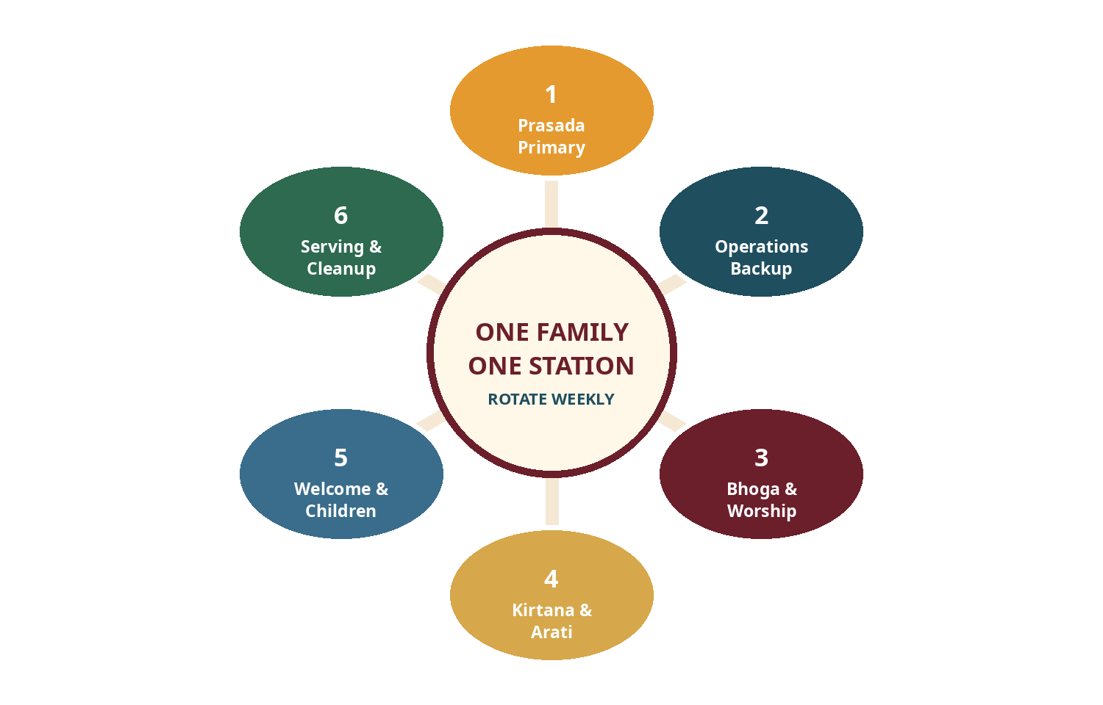
Figure 1. Six independent service stations prevent role confusion and permanent dependency.

5.1 Service stations
Code | Station | Controlled responsibility
P | Prasāda Primary | Prepare, label and transport the approved three-item meal. Complete departure temperature checks.
O | Operations Backup | Prepare venue, warmers and temperature logs; retain emergency-menu capacity; manage contingencies.
B | Bhoga and Worship Support | Receive compliant bhoga, prepare approved utensils and support the authorised offering process.
K | Kīrtana and Ārati | Lead approved kīrtana and prepare instruments and worship materials; no kitchen diversion.
W | Welcome and Children | Attendance, guest orientation, children’s transition and lesson-material readiness.
S | Serving and Cleanup | Set serving line, supervise utensils, coordinate dishes, waste, floors and final reset.

5.2 Six-week rotation
Active week | Family 1 | Family 2 | Family 3 | Family 4 | Family 5 | Family 6
Week 1 | P | O | B | K | W | S
Week 2 | O | B | K | W | S | P
Week 3 | B | K | W | S | P | O
Week 4 | K | W | S | P | O | B
Week 5 | W | S | P | O | B | K
Week 6 | S | P | O | B | K | W

5.3 Rotation rules
• A family may swap roles, but a swap is valid only after the Calendar Lead updates the master roster.
• Routine swaps close Thursday at 8:00 p.m.; emergencies are escalated immediately.
• A missed service is rescheduled fairly and privately, not used for public correction.
• Repeated unreliability is handled under family care and governance, not through gossip.
• The cooking family is exempt from leading cleanup; it may voluntarily help only after its cooking burden is complete.
• Every station lead coordinates helpers but remains accountable for checklist completion.

6. Five-family fallback roster
With five families, six independent stations create hidden overload. The fallback combines adjacent work and requires a short all-adult cleanup rather than assigning two full stations to one family.
Code | Combined station | Responsibility
P | Prasāda Primary | Prepare and transport the meal.
OC | Operations Backup + Cleanup Lead | Setup, holding, emergency food and teardown coordination.
BS | Bhoga + Serving Lead | Offering support, serving line and utensil control.
K | Kīrtana and Ārati | Devotional music and worship readiness.
W | Welcome, Children + Materials | Attendance, guests, child transition and print materials.

Week | Family 1 | Family 2 | Family 3 | Family 4 | Family 5
Week 1 | P | OC | BS | K | W
Week 2 | OC | BS | K | W | P
Week 3 | BS | K | W | P | OC
Week 4 | K | W | P | OC | BS
Week 5 | W | P | OC | BS | K

Cleanup rule All non-cooking adults assist for a focused 15-minute teardown. The OC family coordinates; it does not clean alone.

6.1 When the backup must become the cook
• OC becomes Primary Cook and uses Emergency Menu E1 or E2.
• BS becomes Cleanup Lead.
• W adds Serving Lead after welcome and child transition.
• Optional dishes are cancelled.
• All non-cooking adults participate in teardown.
• The emergency arrangement is recorded; it must not become the standard pattern.

7. First-month training and shadow service
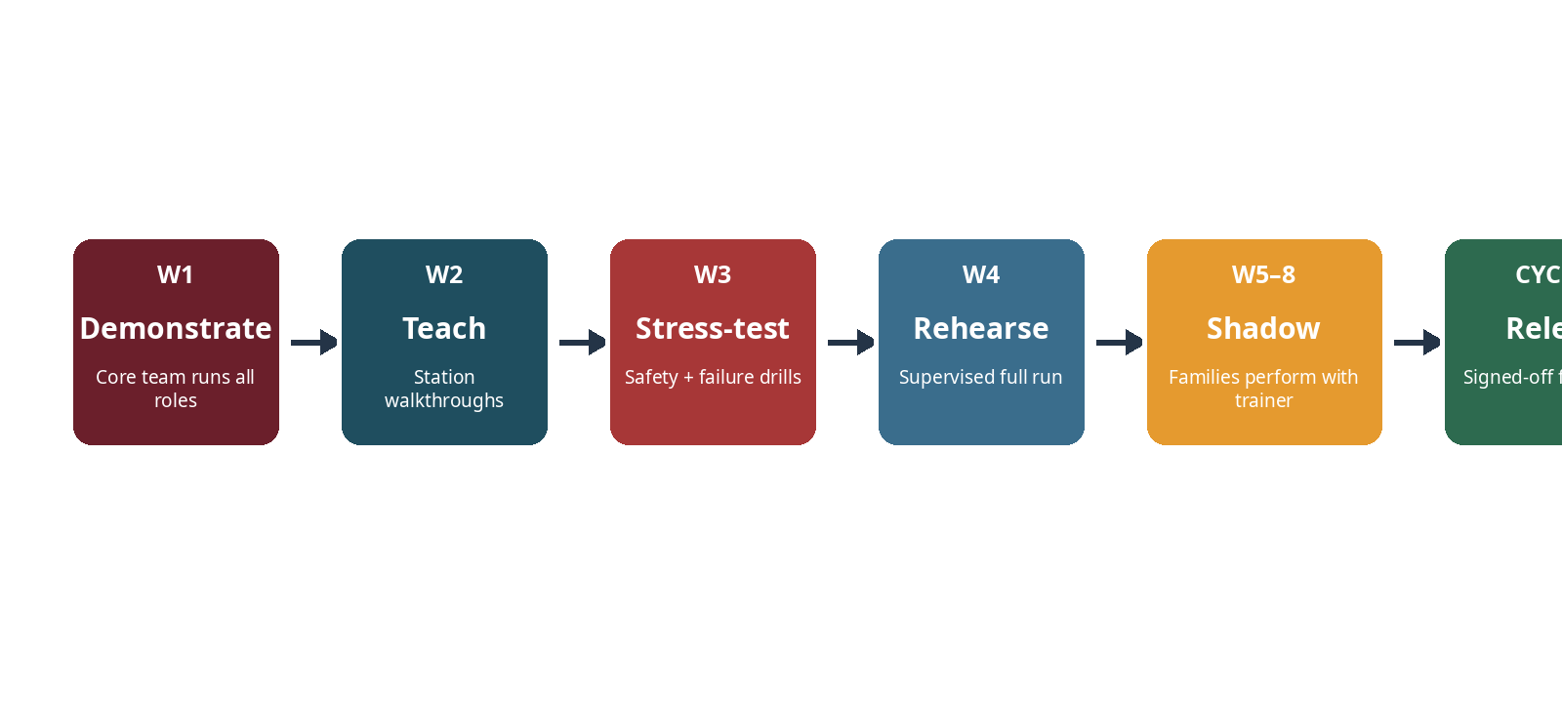
Figure 2. No independent service before demonstration, rehearsal, shadowing and competency release.

7.1 Weeks 1–4: demonstration and rehearsal
Week | Training objective | Required practice
1 — Complete demonstration | See the whole system | Core team runs arrival, bhoga handoff, holding, serving and teardown; families observe.
2 — Station walk-through | Understand role boundaries | Six short demonstrations: recipe card, transport, temperature, offering boundary, welcome and cleanup.
3 — Safety and failure drills | Practise stopping, not improvising | Primary cancellation, unknown ingredient, low arrival temperature, allergy alert and power failure.
4 — Full rehearsal | Operate under direct supervision | Families perform assigned stations; trainers sign only observed competencies.

7.2 Weeks 5–8: shadow service
The assigned family performs the station while a trained core-team member remains accountable. The trainer observes, corrects only when necessary and records objective evidence. A shadow week is not automatic approval.

7.3 Competency release criteria
Role | Minimum evidence before independent assignment
Primary Cook | Follows recipe version; checks packaged ingredients; avoids tasting; labels containers; records departure temperature; arrives on time; escalates changes.
Operations Backup | Sets safe equipment; sanitises probe thermometer; records four temperatures; knows emergency menus; can apply corrective decision tree.
Bhoga Support | Maintains offered/unoffered separation; protects worship utensils; follows the authorised handoff; does not invent procedure.
Kīrtana and Ārati | Uses approved material; sets equipment safely; remains in assigned role; returns assets.
Welcome and Children | Completes attendance; welcomes guests; protects private allergy information; manages child transition and seating.
Serving and Cleanup | Controls utensils; keeps children from heat; applies leftover labels; completes wash-rinse-sanitise-air-dry and final sign-off.

7.4 Training records
Each competency is marked Observed, Practised, Demonstrated or Released. “Attended training” alone does not prove operational competence.

PART III
Prasāda Production System
Standard menus reduce risk, cost, waste and family pressure.

8. Menu architecture

8.1 Standard three-item pattern
Component | Normal selection | Boundary
Grain | Rice, pulao, lemon rice or khichadi base | One only.
Dal / protein preparation | Moong, toor or chana dal; khichadi may combine grain and dal | One only.
Vegetable | One mild seasonal sabji | One only.
Optional | Whole fruit, simple salad, approved raita or one festival sweet | Scheduled, not spontaneous.

No menu inflation An optional item does not authorise five extra preparations. Festival joy is not measured by dish count.

8.2 Approved pilot menus
Code | Preparation 1 | Preparation 2 | Preparation 3
M1 | Plain basmati rice | Yellow moong dal | Aloo-gobi
M2 | Jeera rice | Mild toor dal | Cabbage-peas
M3 | Plain basmati rice | Mild chana dal | Green beans-potato
M4 | Vegetable pulao | Yellow moong dal | Seasonal squash-peas
M5 | Plain basmati rice | Mild toor dal | Spinach-potato
M6 | Vegetable moong-dal khichadi | Cabbage-carrot | Whole fruit
M7 | Nut-free lemon rice | Mild chana dal | Cauliflower-peas
M8 | Plain basmati rice | Yellow moong dal | Mixed seasonal vegetables
E1 | Vegetable khichadi | Whole fruit | Optional sealed pasteurised yogurt only if approved
E2 | Plain rice | Quick moong dal | Frozen mixed-vegetable sabji

8.3 Why eight menus, not forty
• Families learn stable recipes rather than experimenting under pressure.
• Ingredient labels and allergen declarations become predictable.
• Temperature and transport performance can be calibrated.
• Cost and leftover data become comparable.
• Backup families can realistically stock emergency ingredients.
• Children gain familiarity without the menu becoming monotonous.

8.4 Ekādaśī and festival override
Worship approval required The ordinary grain-and-dal menu must not run automatically on Ekādaśī or a fasting/festival observance. Practices can differ by Deity, participant and local authority. The Worship Lead publishes the approved menu and participant guidance at least one week ahead.

Do not create a permanent “Ekādaśī recipe rule” in this operations manual without qualified local review. Food-safety controls still apply to dairy, potatoes, fruit, nuts, refrigeration and cross-contact.

9. Headcount and quantity control

9.1 Adult-equivalent method
Participant | Planning factor
Adult or teen | 1.00
Child age 6–12 | 0.60
Child age 2–5 | 0.35
Child under 2 | Parent-managed; use 0.15 only when a shared portion is expected
Operational buffer | Add 10%, then round to Tier A, B or C

9.2 Portion tiers
Tier | Planned portions | Use
A | 20 | Low-attendance controlled week
B | 25 | Default founding-cohort tier
C | 30 | Approved guests or higher attendance; not an invitation to exceed venue capacity

9.3 Initial production baselines
Preparation family | Tier A (20) | Tier B (25) | Tier C (30)
Raw rice for rice menu | 1.6 kg | 2.0 kg | 2.4 kg
Dry dal | 0.88 kg | 1.10 kg | 1.32 kg
Trimmed vegetables | 3.6–4.0 kg | 4.5–5.0 kg | 5.4–6.0 kg
Khichadi rice | 1.2 kg | 1.5 kg | 1.8 kg
Khichadi split moong | 0.72 kg | 0.90 kg | 1.08 kg
Khichadi vegetables | 2.0–2.4 kg | 2.5–3.0 kg | 3.0–3.6 kg
Whole fruit | 24 pieces | 30 pieces | 36 pieces

Pilot status These are version 0.9 starting quantities, not universal culinary truth. Each recipe must be tested twice locally, measured after offering and adjusted from actual yield and leftovers.

9.4 Quantity-change rules
• The Wednesday headcount produces a planning tier; the Thursday message locks it.
• A family does not independently increase the tier because “more is always better.”
• Known late guests may be absorbed by the 10% buffer; larger changes require Operations approval.
• Leftover percentage is recorded by preparation, not guessed.
• After two cycles, recipe yields are revised based on evidence.

10. Ingredient standard

10.1 Prohibited or excluded ingredients
• Meat, fish and eggs.
• Onion, garlic, shallots, scallions, chives and leeks, including powders and extracts.
• Alcohol, cooking wine and alcohol-containing flavouring unless specifically resolved by worship authority.
• Gelatin or other animal-derived additives; animal-rennet cheese.
• Packaged sauce, stock, paste or spice mix with unknown or noncompliant ingredients.
• Unpasteurised dairy, raw sprouts, low-acid home-canned food and other avoidable high-risk ingredients.
• Peanuts, tree nuts and sesame in the default pilot menus. This reduces exposure but does not create an allergen-free environment.
• Hing/asafoetida in the default pilot recipes unless the product and wheat status are verified and the recipe specifically authorises it.

10.2 Packaged-product verification
The cook reads the full ingredient and “contains” statements every time. Manufacturers can change formulations.
☐ Spice blends and masalas.
☐ Vegetable stock, sauces and pastes.
☐ Frozen vegetables with seasoning.
☐ Yogurt, paneer, cheese and commercial dairy products.
☐ Asafoetida compounds, which commonly use wheat flour.
☐ Bread, crackers, desserts and festival products.
☐ Oils shared with allergen-containing products.
Label honesty Do not call a dish “gluten-free,” “nut-free” or “allergen-free” unless both ingredients and cross-contact controls support that statement. “Prepared without X as an ingredient” is a narrower and more honest claim.

10.3 Default pilot ingredient posture
Category | Default
Cooking oil | Canola or sunflower oil; single-ingredient, clearly labelled
Spice level | Mild; measured from recipe card
Commercial masala | Not used in pilot recipes
Nuts / sesame | Not used in standard communal recipes
Dairy | Used only when declared, pasteurised and temperature-controlled
Fresh garnish | Washed, controlled and added before offering; no bare-hand contact
Salt | Measured; iodised or approved standard
Water | Potable water from approved source

11. Allergy and dietary-management system
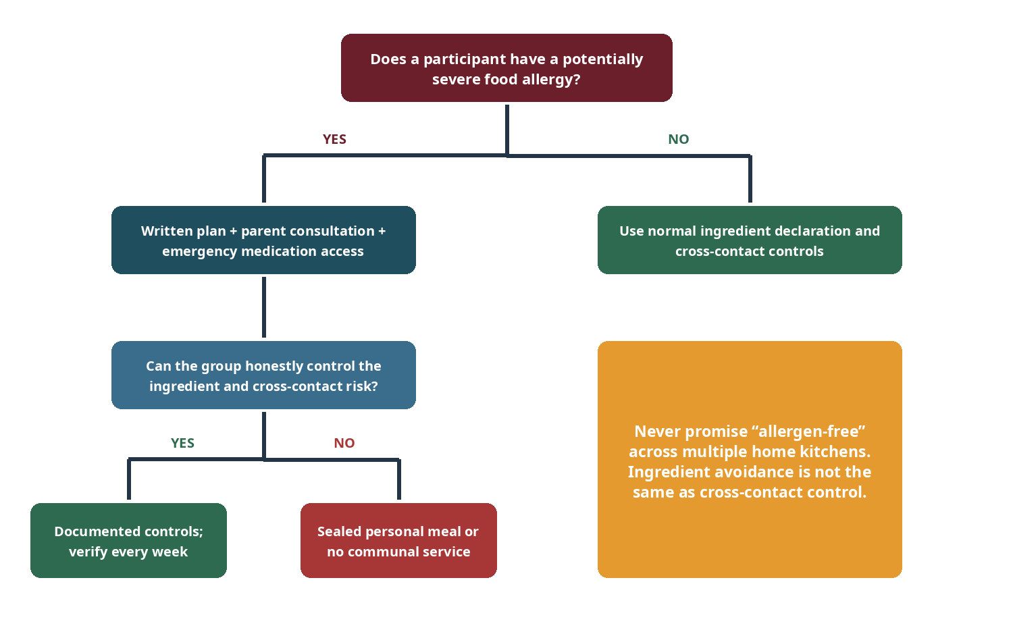
Figure 3. Severe allergy management requires an explicit decision, not an informal promise.

11.1 Required family information
• Participant and parent/guardian names.
• Allergen or intolerance and severity.
• Known symptoms and cross-contact sensitivity.
• Whether food from shared home kitchens is acceptable.
• Emergency medication, location and current action plan.
• Emergency contacts and date reviewed.
• Other dietary restrictions that affect the shared menu.

11.2 Severe-allergy operating rule
For a potentially life-threatening allergy, leadership and the family must choose one documented approach:
Option | Use when | Control
A — Verified communal control | The group can actually control the ingredient and cross-contact risk | Written controls; weekly verification; medication and plan immediately accessible.
B — Sealed personal meal | Multiple home kitchens make cross-contact control unreliable | Participant’s family provides a clearly labelled, separate meal; no shared utensils.
C — No communal meal | Neither A nor B can be made safe | Participant may attend the program but does not consume communal food until resolved.

11.3 Major allergen awareness
U.S. federal labelling recognises nine major food allergens: milk, egg, fish, crustacean shellfish, tree nuts, peanuts, wheat, soybeans and sesame. KUTUMBA’s vegetarian standard excludes several by doctrine, but milk, tree nuts, peanuts, wheat, soy and sesame still require attention.

11.4 Privacy
Medical and allergy data is restricted to authorised leaders and relevant food-service adults. It is not stored in Git, displayed in a public roster or discussed as casual group information. Weekly notices state operational controls without unnecessary diagnosis details.

12. Food-handler health and hygiene

12.1 Illness exclusion
48-hour rule A person with vomiting or diarrhoea does not prepare, transport, offer, serve or clean food, and remains excluded for at least 48 hours after symptoms stop. The family reports the issue without embarrassment and the backup system activates.

12.2 Handwashing and ready-to-eat food
• Wash hands with soap and running water before food work, after restroom use, after handling waste, after touching face or phone and whenever contamination may have occurred.
• Gloves are task-specific and changed when contaminated; they do not replace handwashing.
• Use clean utensils, deli tissue or gloves to avoid bare-hand contact with ready-to-eat food.
• Cover cuts with a waterproof dressing and a glove where appropriate.
• No cooking while simultaneously supervising small children or pets in the food-preparation area.
• Phones remain outside the active preparation zone or are handled only after handwashing.

12.3 Home-kitchen preparation declaration
Each Primary Cook confirms on Friday that the cook was free of exclusion symptoms, the kitchen and utensils were clean, pets were kept out of active preparation, ingredients matched the approved recipe and no one tasted the bhoga.

PART IV
Friday Operations
A weekly rhythm makes the right action obvious before pressure arrives.

13. Weekly communication and escalation
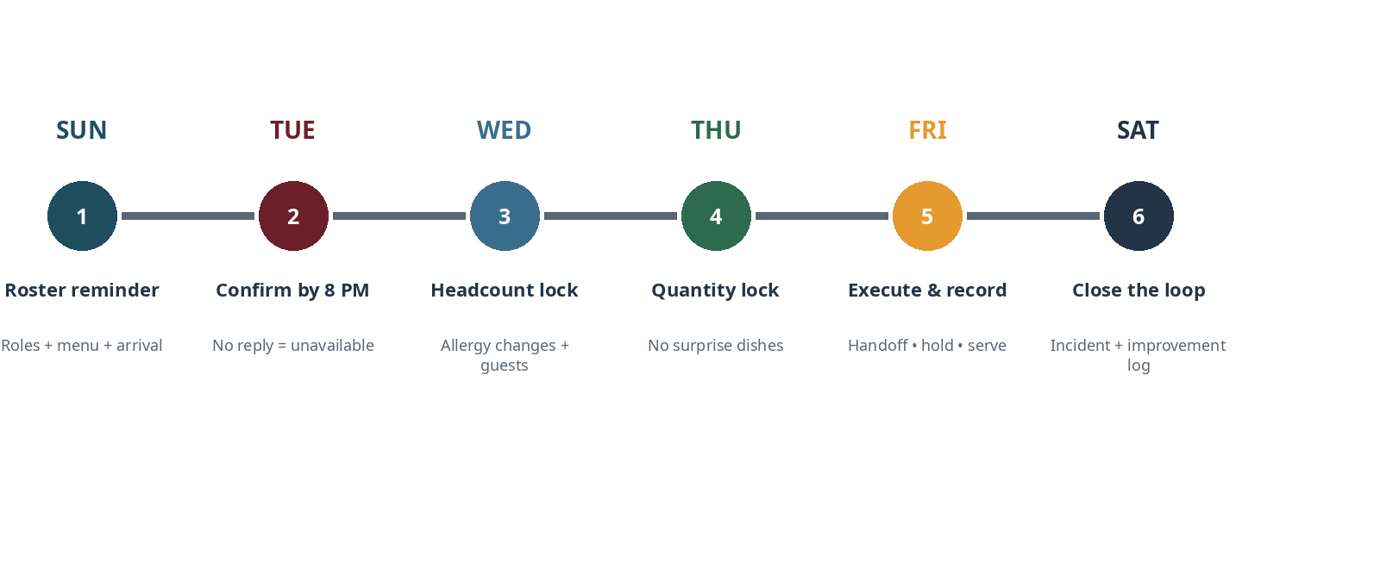
Figure 4. The weekly control cycle resolves uncertainty before Friday.

13.1 Sunday roster reminder
• Date and active-week number.
• All station assignments and named leads.
• Menu code and portion tier.
• Known allergy-control notice.
• Arrival times and equipment owner.
• Primary and escalation contacts.

13.2 Tuesday confirmation
Deadline Every station confirms by Tuesday at 8:00 p.m. At 8:15 p.m. one direct reminder is sent. At 9:00 p.m. no response is treated as unavailable. By 9:30 p.m. the Operations Lead activates the replacement plan.

The Primary Cook confirms menu, ingredient compliance, illness status, transport capacity and expected arrival. The Backup confirms emergency-menu readiness, warmers and thermometer availability. Other stations confirm attendance and role readiness.

13.3 Wednesday and Thursday locks
Control point | Deadline | Output
Headcount and allergy update | Wednesday 6:00 p.m. | Adult/teen/child/guest count; changed dietary or allergy information.
Quantity and equipment lock | Thursday 8:00 p.m. | Tier A/B/C; approved substitutions; equipment assignment; final arrival plan.
No-surprise rule | After Thursday lock | No new dish, major substitution or unverified packaged product without approval.

13.4 Emergency escalation ladder
When primary cancels | Response
Before Wednesday evening | Backup attempts scheduled menu; other station reassigned.
Thursday or Friday before 2:00 p.m. | Use E1 or E2; cancel optional item.
After 2:00 p.m. | Reduced emergency meal, fruit/light service, or no meal. Notify families to eat beforehand if needed.
Food arrives unsafe or noncompliant | Isolate affected item; use emergency food or serve fewer items; no public shaming.
Venue/power/water problem | Apply approved continuity plan or cancel food service/program. Do not improvise around a basic control.

Restaurant rescue is not automatic Outside food may contain onion, garlic, allergens or unclear ingredients and may not fit the approved offering process. Use only a pre-verified supplier or a separately approved emergency protocol.

14. Friday execution timeline
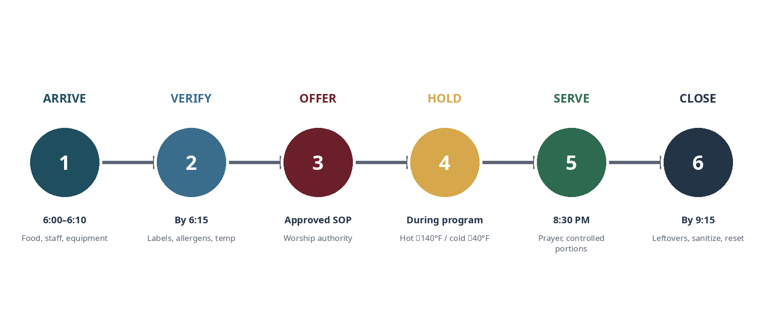
Figure 5. Friday operations move through six controlled gates.
Time | Gate | Required action
5:45–6:00 | Venue access | Operations verifies access, water, power, sanitation supplies and emergency exits.
6:00 | Service arrival | Operations, Primary Cook, Bhoga Support and Serving teams arrive.
6:05 | Equipment setup | Warmers, mats, cables, serving tables and adult-only zones established.
6:10 | Food handoff | Labels, ingredients, illness declaration, container count and departure log reviewed.
By 6:15 | Arrival temperatures | Probe check recorded; corrective action decided before offering.
Before program | Bhoga handoff | Approved portions and utensils transferred to the authorised worship process.
After offering | Status change | Green “OFFERED” labels applied; food placed in controlled hot/cold holding.
7:30–7:45 | Mid-hold check | One designated adult checks food and equipment without disrupting kathā.
8:15–8:20 | Pre-service check | Final temperatures, serving utensils, allergen cards and seating verified.
8:25 | Prasāda prayer | Families assemble; approved prayer led.
8:30 | Serve | Controlled portions; children assisted; seconds only after first pass.
8:50 | Progressive cleanup | Safe, quiet clearing begins where it does not disturb participants.
9:00 | Formal close | Program concludes.
By 9:15 | Final sign-off | Food resolved; equipment off; venue reset by two adults.

15. Transport, temperature and equipment control
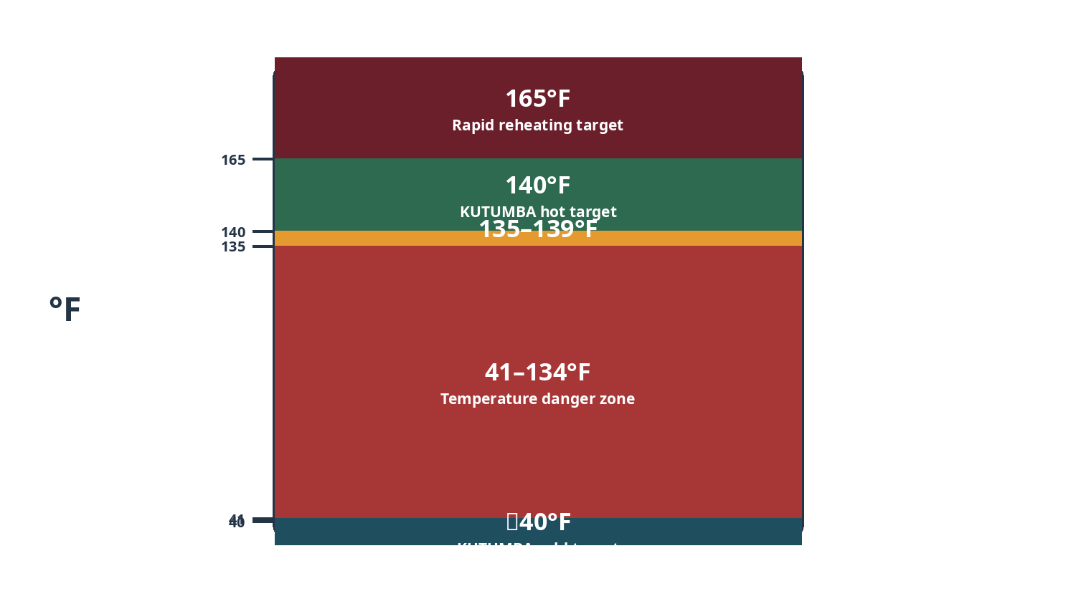
Figure 6. KUTUMBA uses 140°F/40°F internal targets, with 135°F/41°F as the FDA/PA model-code holding limits.

15.1 Temperature standards
Control | KUTUMBA target | Action boundary
Hot holding | 140°F or above | 135–139°F: correct and recheck; below 135°F: determine time and reheat/discard.
Cold holding | 40°F or below | 41°F is the model-code ceiling; above 41°F: determine time and correct/discard.
Reheating cooked/cooled TCS food for hot holding | 165°F for 15 seconds, reached rapidly | Use stovetop, oven or microwave; a warmer is not a reheater.
Room-temperature exposure | Use a strict two-hour cumulative operating limit | One hour where ambient temperature exceeds 90°F.
Cooling retained leftovers | Shallow containers; refrigerate promptly | Do not place a deep hot pot in a crowded refrigerator and assume it cools safely.

15.2 Four temperature checks
• Departure from the cook’s home.
• Arrival at the venue.
• Mid-hold during the program.
• Immediately before serving.
The probe is cleaned and sanitised between foods. The reading is taken from the thermal centre and, for large containers, more than one location.

15.3 Corrective decision tree
Observation | Action
Hot food ≥140°F | Accept and hold. Recheck on schedule.
Hot food 135–139°F | Accept only as corrective buffer; raise holding performance and recheck within 15 minutes.
Hot food <135°F, known to be out of control less than 2 hours | Rapidly reheat to 165°F for 15 seconds using proper cooking equipment; then hold ≥140°F.
Hot food <135°F, time unknown or ≥2 hours under KUTUMBA rule | Do not serve; discard respectfully.
Cold food ≤40°F | Accept and hold.
Cold food 41°F, brief verified exposure | Correct immediately and recheck.
Cold food >41°F, time unknown or ≥2 hours under KUTUMBA rule | Do not serve; discard.
Thermometer absent or unreliable | Use a verified backup. If temperature cannot be verified, the item does not proceed.

15.4 Transport requirements
• Preheat insulated hot carriers and pre-chill cold carriers where appropriate.
• Keep containers closed, upright, food-grade and secured against tipping.
• Separate food from chemicals, shoes, pets and unrelated cargo.
• Do not rely on a car cabin temperature to hold food safely.
• Use direct transport; avoid errands between cooking and the venue.
• Log departure time and temperature on every TCS container group.

15.5 Warming and electrical safety
• Verify each warmer can maintain the required temperature with actual food; appliance names are not evidence.
• Place warmers on heat-resistant mats in an adult-only zone.
• Follow manufacturer instructions and venue/fire requirements.
• No daisy-chained power strips, overloaded circuits, cords under rugs or cords across child walkways.
• Use cable covers or secured routing approved by the venue.
• Open-flame chafers are not part of the pilot unless explicitly permitted and controlled.
• One adult is assigned to equipment checks; children and teens do not troubleshoot electrical equipment.

16. Bhoga handoff and authorised offering boundary

16.1 Status labels
Label | Colour | Meaning
UNOFFERTED BHOGA — DO NOT TASTE OR SERVE | Yellow | Received and controlled, but not yet authorised for serving.
OFFERED — READY FOR CONTROLLED HOLDING | Green | Worship Lead confirms the approved offering process is complete.
HOLD — DO NOT SERVE | Red | Ingredient, allergy, temperature, contamination or status question is unresolved.

16.2 Handoff sequence
• Primary Cook transfers containers directly to Operations and Bhoga Support.
• Container count, menu code, ingredient declaration and no-tasting status are confirmed.
• Arrival temperatures are measured and recorded.
• Approved offering portions and worship-only utensils are prepared.
• Only the locally authorised person performs the offering according to the approved SOP.
• Worship Lead confirms completion and the green label is applied.
• Food moves immediately to controlled holding.
• No person samples or serves food before the green status is confirmed.

16.3 What this manual does not prescribe
This manual does not independently prescribe mantras, altar placement, offering duration, Deity-specific procedure, whether a complete batch or representative plate is offered, or who is qualified to perform the offering. Those matters are controlled by the approved worship SOP and qualified authority.
Reason for the boundary The operational system must prevent confusion without manufacturing or casually altering worship standards.

17. Serving, hospitality and child seating

17.1 Serving order
After the approved prasāda prayer: participants with documented dietary arrangements; young children with parents; other children; adults; then servers after the first pass. Moderate first portions protect fairness and reduce waste.

17.2 Serving controls
• One clean, dedicated utensil per preparation.
• Used personal utensils never enter common food containers.
• Children do not self-serve from hot vessels.
• Ingredient/allergen cards remain visible at the line.
• Water is available before service begins.
• Seconds begin only after everyone has a first opportunity.
• Ready-to-eat garnish and fruit are handled with utensils or clean gloves.
• No comments on another participant’s portion, weight, diet or appetite.

17.3 Hospitality standard
• Welcome guests without interrogating spiritual background or food choices.
• Explain prasāda etiquette briefly and naturally.
• Do not pressure anyone to eat a preparation that conflicts with their health or documented plan.
• Do not turn late arrival into a public correction.
• Treat servers and cleaners as participants, not invisible labour.
• Close the formal evening on time; hospitality does not require uncontrolled lingering.

17.4 Child seating
Group | Pilot standard
Under six | Seated with parent or designated caregiver; away from warmers, cords and serving traffic.
Age 6–12 | May sit together only with two adults visibly nearby and parents in the room; adults serve hot food.
Teens | May distribute plates, reset chairs and count dry inventory; do not own temperature, hot vessels, allergy response or younger-child safety.
Choking controls | Parents manage age-appropriate food; do not serve whole grapes, hard candy or similar avoidable hazards to young children.

18. Cleanup, offered food and leftovers

18.1 Cleanup zones
Zone | Purpose
1 — Return | Used plates and utensils arrive without crossing the clean service line.
2 — Scrape / leftover | Food is separated; retained portions are labelled; waste is contained.
3 — Wash | Food soil removed with detergent and appropriate water.
4 — Rinse and sanitise | Venue-approved method and sanitiser concentration used.
5 — Air-dry and reset | No towel-drying of food-contact items; dry items return to labelled storage.

18.2 Cleanup assignment
• Serving and Cleanup station coordinates, but does not perform all work alone.
• Assign adults to dishes, tables/chairs, waste/floors and asset reset.
• Primary Cook family is exempt from leading cleanup.
• Children may perform safe, age-appropriate dry tasks only.
• Two adults complete the final venue walk-through.

18.3 Leftover hierarchy
Priority | Action
1 | Offer reasonable seconds after everyone is served.
2 | Package safe remaining prasāda promptly in clean, shallow, labelled containers.
3 | Distribute only when time/temperature history is known and safe.
4 | Refrigerate promptly where the venue permits and the recipient can maintain control.
5 | Discard food when time, temperature, contamination or allergen status is uncertain.

18.4 Take-home label
Every retained container states preparation, date/time packed, known allergens, “keep refrigerated,” and “reheat to 165°F.” Routine carry-forward to the next KUTUMBA Friday is prohibited.
Respect and safety Discard unsafe prasāda respectfully. Distributing questionable food merely to avoid waste transfers the risk to another family and is not responsible service.

PART V
Assets, Finance and Assurance
Good operations make reliability visible without creating bureaucracy.

19. Equipment, storage and inventory

19.1 Minimum pilot equipment
Category | Minimum controlled assets
Food safety | 3 digital probe thermometers; sanitising wipes; insulated hot carriers; cold coolers and ice packs; heat-resistant mats.
Holding and serving | 2–3 verified electric warmers; dedicated ladles/tongs/rice paddles; water pitchers; allergen-display stands; clean take-home containers.
Electrical | Venue-approved power strips or extension leads, cable covers/gaffer tape and documented circuit plan.
Audio/kīrtana | Speaker, wired microphone and backup, stands, labelled cables, batteries, kartālas, mṛdaṅgas and approved storage.
Children/operations | Attendance clipboard, name labels, floor mats, lesson bins, first-aid kit and restricted emergency-contact folder.

19.2 Storage zoning
Zone | Contents | Separation rule
A — Worship/bhoga | Offering plates, bowls, spoons, approved cloths and labels | Separate from general service utensils.
B — Food service | Serving utensils, thermometers, carriers, mats and lids | Clean, dry and food-contact protected.
C — Consumables | Plates, bowls, cups, napkins, gloves, foil, labels and bags | Use par levels and monthly count.
D — Audio/instruments | Microphones, cables, speaker, batteries and instruments | No food or liquid stored above.
E — Children/print | Attendance, worksheets, craft materials and mats | No medical records in open bins.
F — Chemicals | Sanitiser, cleaners and waste supplies | Locked/separate; never above food, utensils or worship assets.

19.3 Consumable par levels for 25 people
Item | Restock point | Target stock
Plates / bowls / cups / spoons | 30 each | 75 each
Napkins | 50 | 150
Take-home containers | 10 | 30
Food/status labels | 25 | 100
Large waste bags | 5 | 15
Paper towels | 3 rolls | 8 rolls
Food-safe gloves | 25 pairs | 75 pairs
Thermometer sanitising wipes | 1 pack | 3 packs

20. Setup and teardown standards

20.1 Setup gates
☐ Access, water, restrooms and emergency exits confirmed.
☐ Tables, chairs, child areas and walkways positioned.
☐ Warmers, mats, electrical routing and adult-only boundary installed.
☐ Thermometers and sanitising supplies available.
☐ Bhoga utensils clean and separate; status labels ready.
☐ Audio tested; cables secured; instruments placed.
☐ Attendance, guest and child materials ready.
☐ Allergy control available to authorised adults without public display.

20.2 Teardown gates
☐ All food distributed, refrigerated, labelled or discarded.
☐ No unidentified containers remain in refrigerator or kitchen.
☐ Warmers off, cooled and stored; electrical equipment unplugged.
☐ Food-contact and worship utensils cleaned and returned separately.
☐ Tables, chairs, floors, child areas and restrooms checked as required.
☐ Waste removed and chemicals returned to secure storage.
☐ Instruments, microphones, cables and print assets counted.
☐ Damage, shortage or incident recorded.
☐ Two-adult final walk-through complete.

21. Cost tracking and future funding

21.1 Pilot rule: no pooled money
• No mandatory common fund during the first six months.
• No personal Venmo, Zelle or cash box functioning as an unofficial treasury.
• No public comparison of family spending.
• No reimbursement promise without prior approval.
• Shared equipment and consumables still require a named purchaser/owner and record.

21.2 Private cost evidence
The cook records menu code, tier, grocery cost, ingredients already owned, donated ingredients, container cost and leftover estimate. Operations records shared consumables, equipment, replacements and venue costs. Individual spending remains private.

21.3 Six-month decision
Option | Advantage | Risk / condition
Continue in-kind rotation | Minimal administration | Hidden or uneven burden; monitor hardship.
Optional contribution | Flexible | Unpredictable; can create embarrassment.
Fixed family contribution | Predictable | Requires hardship waiver, accounting and transparent governance.
Temple-managed designated fund | Best institutional accountability | Requires approval and alignment with temple financial process.
Approved sponsorship/fundraiser | Can fund equipment or outings | May distract from formation and trigger event/food rules.

Recommendation Use in-kind service for six months. Then prefer a temple-managed designated fund or a small transparent contribution with a confidential hardship waiver. Do not build a permanent treasury through an individual.

22. Records, privacy and document control

22.1 Public/family-facing records
• Annual calendar and roster.
• Approved menu and ingredient guide.
• General checklists and weekly reminder.
• Equipment instructions and non-private emergency procedure.

22.2 Restricted records
• Allergy/medical forms and action plans.
• Family contact details and attendance history.
• Incident reports and private reliability concerns.
• Individual cost records and hardship information.

22.3 Repository boundary
Git stores templates, approved policies, blank forms, recipes and version history. It never stores completed medical forms, child records, attendance, phone numbers, mentor notes, tokens or passwords.

22.4 Change control
Change type | Approval
Typo or layout correction | Documentation Lead
Recipe quantity after pilot evidence | Operations Lead; record version and effective date
Ingredient/allergen change | Operations + Safety; notify families before use
Offering-process change | Worship Lead + qualified authority
Venue or legal change | Temple Liaison / venue authority
Major service-model change | Core team review at cycle boundary

23. Incident response and continuity

23.1 Food-safety incident
• Stop service of affected food.
• Isolate and label it “HOLD — DO NOT SERVE.”
• Record time, temperature, ingredients, persons and actions.
• Preserve packaging/labels where relevant.
• Use emergency meal or reduce service.
• Seek medical or regulatory assistance when indicated.
• Review before the next active week without public blame.

23.2 Allergy incident
• Follow the participant’s current emergency action plan.
• Use emergency services when indicated; do not delay for group discussion.
• Notify parent/guardian.
• Preserve ingredient and cross-contact evidence.
• Document privately.
• Suspend the relevant recipe/control until reviewed.

23.3 Suspected foodborne illness after the program
• Collect facts without diagnosing: people affected, symptoms, timing and foods consumed.
• Tell affected families to seek appropriate medical advice.
• Preserve recipe, labels, temperature logs and leftovers only when safe to do so.
• Notify venue/regulator according to applicable requirements.
• Pause implicated recipes or processes.
• Do not use group chat for speculation or blame.

23.4 Continuity priorities
Priority | Preserve
1 | Human safety and medical response
2 | Worship integrity and honest food status
3 | Clear family communication
4 | A reduced but orderly program
5 | Meal completeness and convenience

24. Quality review and operational measures
Review after every six active weeks. Metrics exist to improve the system, not rank families.
Measure | Initial target
Tuesday confirmation | 100% by deadline or replacement activated
Ingredient declaration | 100% for every preparation
Temperature records | Four checks for each applicable TCS food group
Allergy controls | No unresolved exposure; plan followed
Start of serving | Within 10 minutes of planned time
Teardown | Complete by approximately 9:15 p.m.
Role separation | Cooking family does not lead cleanup
Avoidable leftovers | Trend toward ≤10% after calibration
Emergency activations | Root cause reviewed; not normalised
Equipment/inventory defects | Closed before next applicable use

24.1 Review questions
• What nearly failed even though the evening appeared successful?
• Which control depends on one person’s memory?
• Which recipe or quantity produced recurring excess or shortage?
• Which station is too large or unclear?
• Was any family carrying hidden financial or time burden?
• Did the system protect the devotional mood or create kitchen distraction?
• What one change should be tested next cycle?

25. Implementation roadmap and launch gates

25.1 Build sequence
Stage | Deliverables
1 — Authority and venue | Name leads; verify venue, insurance, food/electrical boundaries and worship authority.
2 — Controlled materials | Approve ingredient guide, allergy form, illness rule, menu library, recipes and checklists.
3 — Assets | Buy/label thermometers, carriers, warmers, utensils, racks and consumables.
4 — Training | Run four demonstration/rehearsal weeks and four shadow weeks.
5 — Pilot | Operate two six-week cycles; log costs, temperature, waste and failures.
6 — Stabilise | Revise recipes/roles; decide funding only from evidence.

25.2 Launch gate checklist
☐ Venue and jurisdiction questions answered in writing.
☐ Operations, Worship, Safety and Calendar owners appointed.
☐ Exact bhoga/offer SOP approved by qualified local authority.
☐ Allergy/dietary forms collected and severe-allergy decisions documented.
☐ Food-handler illness exclusion communicated to every family.
☐ Eight menus and two emergency menus approved.
☐ Each recipe tested at least twice or clearly marked pilot under direct core-team control.
☐ Thermometers verified; warmers tested with food; electrical layout approved.
☐ Storage racks and assets labelled.
☐ Weeks 1–8 training and shadow roster published.
☐ Restricted record storage established.
☐ Six-week family roster published and acknowledged.
No-go rule Do not launch full rotation with unresolved venue permission, severe-allergy control, offering authority or food-temperature capability. These are not “we will figure it out” items.

APPENDICES
Implementation Toolkit
Print, train, operate and audit from these controlled templates.

Appendix A — Forty-active-week menu calendar
Use active-week numbers, not ordinary Fridays. Off weeks, festivals and outings do not consume a menu code. The Worship Lead replaces any ordinary menu affected by Ekādaśī or a fasting observance.
Active weeks | Week 1 | Week 2 | Week 3 | Week 4
1–4 | M1 | M2 | M3 | M4
5–8 | M5 | M6 | M7 | M8
9–12 | M1 | M2 | M3 | M4
13–16 | M5 | M6 | M7 | M8
17–20 | M1 | M2 | M3 | M4
21–24 | M5 | M6 | M7 | M8
25–28 | M1 | M2 | M3 | M4
29–32 | M5 | M6 | M7 | M8
33–36 | M1 | M2 | M3 | M4
37–40 | M5 | M6 | M7 | M8

Festival replacement: ______________________________________ Approved by: ____________________ Date: __________

Appendix B — Six-family roster worksheet
Cycle / dates: ______________________________________________________________________
Family names (1–6): ______________________________________________________________________
Week | Family 1 | Family 2 | Family 3 | Family 4 | Family 5 | Family 6
1 | P | O | B | K | W | S
2 | O | B | K | W | S | P
3 | B | K | W | S | P | O
4 | K | W | S | P | O | B
5 | W | S | P | O | B | K
6 | S | P | O | B | K | W

Swaps are valid only after the master roster is updated.
Approved swap / reason: ______________________________________________________________________
Calendar updated by / date: ______________________________________________________________________

Appendix C — Five-family fallback worksheet
Cycle / dates: ______________________________________________________________________
Family names (1–5): ______________________________________________________________________
Week | Family 1 | Family 2 | Family 3 | Family 4 | Family 5
1 | P | OC | BS | K | W
2 | OC | BS | K | W | P
3 | BS | K | W | P | OC
4 | K | W | P | OC | BS
5 | W | P | OC | BS | K

Fallback rule All non-cooking adults assist the OC lead with a focused final cleanup.

Appendix D — Family allergy and dietary information form
Restricted record Do not store completed forms in Git or a public folder.

Participant name ______________________________________________________________________
Parent / guardian ______________________________________________________________________
Date of birth (child only, if needed) ______________________________________________________________________
Primary phone ______________________________________________________________________
Emergency contact ______________________________________________________________________
Date completed / reviewed ______________________________________________________________________

Food allergy / intolerance / restriction
Food or ingredient ______________________________________________________________________
Severity and typical reaction ______________________________________________________________________
Cross-contact sensitivity ______________________________________________________________________
Is food from shared home kitchens acceptable? YES / NO / CONDITIONAL ______________________________________________________________________
Required conditions ______________________________________________________________________

Emergency plan
Medication carried and location ______________________________________________________________________
Current action plan attached? YES / NO ______________________________________________________________________
Who is authorised/trained to assist? ______________________________________________________________________
Other instructions ______________________________________________________________________
I understand that food prepared in multiple private homes cannot be guaranteed allergen-free unless a specific written control plan has been approved.
Parent / adult signature ______________________________________________________________________
Safety Lead review / date ______________________________________________________________________

Appendix E — Severe-allergy control plan
Decision field | Controlled response
Allergen / participant
Selected approach | A — verified communal control / B — sealed personal meal / C — no communal meal
Prohibited ingredient sources
Cross-contact controls
Dedicated utensils / storage
Weekly verification owner
Medication location
Emergency action-plan date
Parent responsibilities
Operations responsibilities
Stop conditions
Next review date

Parent / adult signature ______________________________________________________________________
Safety Lead ______________________________________________________________________
Operations Lead ______________________________________________________________________

Appendix F — Tuesday service confirmation
Send by Sunday; response due Tuesday 8:00 p.m.
Friday date ______________________________________________________________________
Active week ______________________________________________________________________
Family ______________________________________________________________________
Assigned role ______________________________________________________________________
Menu / tier ______________________________________________________________________
Required arrival ______________________________________________________________________
☐ I can perform the assigned role.
☐ I reviewed the current checklist.
☐ I can meet the arrival time.
☐ I have declared any substitution, equipment or transport issue.
☐ I reviewed the allergy-control notice relevant to my role.
☐ No food handler in my plan currently has an exclusion illness.
Response: CONFIRMED / NEED ASSISTANCE ______________________________________________________________________
Issue / requested support ______________________________________________________________________

Appendix G — Wednesday headcount and Thursday quantity lock
Count | Number
Adults
Teens
Children 6–12
Children 2–5
Children under 2
Guests
Adult-equivalent total + 10%
Locked tier: A / B / C

Changed allergy or dietary information ______________________________________________________________________
Approved substitutions ______________________________________________________________________
Equipment owner ______________________________________________________________________
Operations approval / date and time ______________________________________________________________________

Appendix H — Friday operations and temperature log
Date ______________________________________________________________________
Menu code / tier ______________________________________________________________________
Primary Cook ______________________________________________________________________
Operations Lead ______________________________________________________________________
Preparation | Departure time / °F | Arrival time / °F | Mid-hold time / °F | Pre-serve time / °F | Corrective action

☐ Probe cleaned/sanitised between foods.
☐ Warmer capability verified.
☐ All corrections completed before serving.
☐ Unknown time/temperature items isolated.
Operations sign-off ______________________________________________________________________
Worship offering status confirmed by ______________________________________________________________________
Final service decision ______________________________________________________________________

Appendix I — Container and bhoga status labels
UNOFFERTED BHOGA — DO NOT TASTE OR SERVE | OFFERED — READY FOR CONTROLLED HOLDING | HOLD — DO NOT SERVE
Menu / preparation: __________ | Menu / preparation: __________ | Reason: ____________________
Cook family: _______________ | Offering confirmed by: _______ | Operations owner: ___________
Allergens: __________________ | Time: _______________________ | Time isolated: ______________
Departure temp/time: ________ | Holding method: _____________ | Next decision by: ___________
Container ___ of ___ | Container ___ of ___ | Container ___ of ___

Appendix J — Food-handler health declaration
Complete verbally or in writing each Friday for the Primary Cook and any person handling ready-to-eat food.
☐ No vomiting or diarrhoea in the previous 48 hours.
☐ No active illness that makes safe food handling unreliable.
☐ Cuts are covered appropriately.
☐ Hands, clothing, preparation area and utensils were clean.
☐ Pets were excluded from the active food-preparation area.
☐ No one tasted the bhoga.
☐ Ingredients and packaged labels matched the approved recipe.
☐ Food was transported directly under temperature control.
Name / role ______________________________________________________________________
Signature / confirmation time ______________________________________________________________________

Appendix K — Setup checklist
☐ Venue access, potable water and restrooms confirmed.
☐ Emergency exits and walkways clear.
☐ Tables/chairs and child areas positioned.
☐ Warmers on heat-resistant mats in adult-only zone.
☐ Electrical circuits and cable routing checked.
☐ Thermometers and sanitising supplies present.
☐ Food handoff area ready.
☐ Bhoga utensils/status labels ready and separate.
☐ Audio tested; cables secured; instruments ready.
☐ Attendance, guest and child materials ready.
☐ Allergy-control information available only to authorised adults.
☐ Waste and cleaning stations prepared.
Setup Lead / completion time ______________________________________________________________________
Issue and corrective action ______________________________________________________________________

Appendix L — Teardown and sanitation checklist
☐ Leftovers distributed, refrigerated, labelled or discarded.
☐ No unidentified containers remain.
☐ Warmers off, cooled and stored.
☐ Electrical equipment unplugged and cables stored.
☐ Thermometers cleaned and returned.
☐ Food-contact items washed, rinsed, sanitised and air-dried.
☐ Worship utensils returned separately.
☐ Tables/chairs reset; floors and child areas checked.
☐ Waste removed and chemicals secured.
☐ Instruments/audio/print assets counted.
☐ Damage, shortage or incident documented.
☐ Two-adult final walk-through completed.
Cleanup Lead ______________________________________________________________________
Second adult ______________________________________________________________________
Venue close time ______________________________________________________________________

Appendix M — Take-home prasāda label
TAKE-HOME PRASĀDA
Preparation: ___________________________________________
Packed date/time: ______________________________________
Known allergens: _______________________________________
KEEP REFRIGERATED. REHEAT TO 165°F.
Do not consume if time/temperature history becomes uncertain.

Appendix N — Incident report
Date / time ______________________________________________________________________
Location ______________________________________________________________________
Reported by ______________________________________________________________________
People involved ______________________________________________________________________
Incident category: food safety / allergy / injury / equipment / worship-status / other ______________________________________________________________________
Objective description _______________________________________________________
___________________________________________________________________________
___________________________________________________________________________
Food / equipment / container involved ______________________________________________________________________
Temperature / time evidence ______________________________________________________________________
Ingredient or label evidence ______________________________________________________________________
Immediate action ______________________________________________________________________
Medical or emergency services ______________________________________________________________________
Venue / authority notification ______________________________________________________________________
Food isolated or discarded ______________________________________________________________________
Follow-up owner and due date ______________________________________________________________________
Root cause / corrective change ______________________________________________________________________
Closed by / date ______________________________________________________________________

Appendix O — Cost, yield and waste log
Date | Menu / tier | Groceries | Owned/donated | Containers | Finished yield | Leftover | Notes

Individual family costs remain private. Aggregate data is used only to simplify menus, reduce waste and assess future funding.

Appendix P — Inventory count sheet
Asset / consumable | Par level | On hand | Condition / expiry | Action / owner
Plates
Bowls
Cups
Spoons
Napkins
Take-home containers
Labels
Gloves
Paper towels
Waste bags
Thermometers
Warmers
Carriers/coolers
Serving utensils
Microphones/cables
Instruments

Appendix Q — Station competency sign-off
Participant / family ______________________________________________________________________
Station ______________________________________________________________________
Trainer ______________________________________________________________________
Competency | Observed | Practised | Demonstrated | Released / notes
Uses current checklist
States role boundary and stop conditions
Completes setup correctly
Handles safety/privacy controls
Responds to one failure scenario
Completes records
Completes teardown/asset return

Release decision: READY / MORE SHADOWING REQUIRED ______________________________________________________________________
Trainer signature / date ______________________________________________________________________
Next review ______________________________________________________________________

Appendix R — Weekly improvement review
Date / active week ______________________________________________________________________
Reviewer(s) ______________________________________________________________________
Question | Finding / action
What nearly failed?
Was any safety or offering status unclear?
Was the quantity tier correct?
Which preparation produced shortage or waste?
Did a role depend on one person’s memory?
Did service distract from kīrtana or kathā?
Was any family overloaded financially or operationally?
One change to test next week/cycle

RECIPE LIBRARY
Standardised Pilot Recipe Cards
Version 0.9 quantities require two local tests before independent family release.

G01 | Plain Basmati Rice
Category: Grain • Recipe status: PILOT v0.9 • Test twice before independent release
Allergen statement None of the nine major allergens by ingredient; verify rice and oil labels/cross-contact.

Ingredient | Tier A — 20 | Tier B — 25 | Tier C — 30
Basmati rice | 1.6 kg | 2.0 kg | 2.4 kg
Water | 2.8–3.2 L | 3.5–4.0 L | 4.2–4.8 L
Canola/sunflower oil | 80 mL | 100 mL | 120 mL
Salt | 28 g | 35 g | 42 g

Controlled method
1. Rinse rice until water is mostly clear; drain.
2. Cook using the tested pot/rice-cooker ratio. Water amount must be calibrated to equipment and rice brand.
3. Rest covered 10 minutes; fluff with a clean utensil. Do not taste.
4. Transfer to clean pre-warmed containers; record departure temperature.

Holding and transport
Hold ≥140°F. Avoid prolonged low-heat drying; use covered shallow hotel pans where possible.

Pilot validation record
Test | Date / cook | Actual yield | Leftover / shortage | Adjustment approved
1
2

Operations release / effective version ______________________________________________________________________

G02 | Jeera Rice
Category: Grain • Recipe status: PILOT v0.9 • Test twice before independent release
Allergen statement None by ingredient; verify spice/oil cross-contact.

Ingredient | Tier A — 20 | Tier B — 25 | Tier C — 30
Basmati rice | 1.6 kg | 2.0 kg | 2.4 kg
Water | 2.8–3.2 L | 3.5–4.0 L | 4.2–4.8 L
Oil | 100 mL | 125 mL | 150 mL
Cumin seed | 24 g | 30 g | 36 g
Salt | 28 g | 35 g | 42 g

Controlled method
1. Rinse and drain rice.
2. Heat oil; bloom measured cumin without burning.
3. Add rice, water and salt; cook using validated equipment ratio.
4. Rest, fluff, cover, label and temperature-check.

Holding and transport
Hold ≥140°F; keep covered.

Pilot validation record
Test | Date / cook | Actual yield | Leftover / shortage | Adjustment approved
1
2

Operations release / effective version ______________________________________________________________________

G03 | Vegetable Pulao
Category: Grain + vegetables • Recipe status: PILOT v0.9 • Test twice before independent release
Allergen statement None by ingredient; verify frozen vegetable/spice labels.

Ingredient | Tier A — 20 | Tier B — 25 | Tier C — 30
Basmati rice | 1.45 kg | 1.80 kg | 2.16 kg
Mixed vegetables, plain | 1.2 kg | 1.5 kg | 1.8 kg
Water | 2.8 L | 3.5 L | 4.2 L
Oil | 120 mL | 150 mL | 180 mL
Cumin seed | 24 g | 30 g | 36 g
Turmeric | 8 g | 10 g | 12 g
Salt | 32 g | 40 g | 48 g

Controlled method
1. Verify vegetables contain no seasoning/sauce. Rinse rice.
2. Bloom cumin in oil; add vegetables and turmeric.
3. Add rice, measured water and salt; cook completely.
4. Rest, fluff, cover, label and record temperature.

Holding and transport
Hold ≥140°F. Because vegetables increase moisture variability, validate in the actual cooker.

Pilot validation record
Test | Date / cook | Actual yield | Leftover / shortage | Adjustment approved
1
2

Operations release / effective version ______________________________________________________________________

G04 | Nut-Free Lemon Rice
Category: Grain • Recipe status: PILOT v0.9 • Test twice before independent release
Allergen statement Prepared without peanuts/tree nuts/sesame. Mustard is omitted in pilot recipe; verify spice cross-contact.

Ingredient | Tier A — 20 | Tier B — 25 | Tier C — 30
Basmati rice | 1.6 kg | 2.0 kg | 2.4 kg
Water | 2.8–3.2 L | 3.5–4.0 L | 4.2–4.8 L
Oil | 100 mL | 125 mL | 150 mL
Cumin seed | 20 g | 25 g | 30 g
Turmeric | 8 g | 10 g | 12 g
Fresh lemon juice | 160 mL | 200 mL | 240 mL
Salt | 28 g | 35 g | 42 g

Controlled method
1. Cook rice and rest until grains are set.
2. Bloom cumin in oil; add turmeric.
3. Fold seasoning, measured lemon juice and salt into rice with clean utensils. Do not taste.
4. Cover, label and record temperature.

Holding and transport
Hold ≥140°F. Add lemon while food remains under temperature control.

Pilot validation record
Test | Date / cook | Actual yield | Leftover / shortage | Adjustment approved
1
2

Operations release / effective version ______________________________________________________________________

K01 | Vegetable Moong-Dal Khichadi
Category: Emergency / combined grain-dal • Recipe status: PILOT v0.9 • Test twice before independent release
Allergen statement None by ingredient; verify rice, dal, oil and frozen vegetables.

Ingredient | Tier A — 20 | Tier B — 25 | Tier C — 30
Rice | 1.2 kg | 1.5 kg | 1.8 kg
Split yellow moong dal | 0.72 kg | 0.90 kg | 1.08 kg
Vegetables | 2.0–2.4 kg | 2.5–3.0 kg | 3.0–3.6 kg
Water | 7.2–8.0 L | 9.0–10.0 L | 10.8–12.0 L
Oil | 120 mL | 150 mL | 180 mL
Cumin seed | 24 g | 30 g | 36 g
Turmeric | 12 g | 15 g | 18 g
Salt | 40 g | 50 g | 60 g

Controlled method
1. Rinse rice and dal thoroughly.
2. Bloom cumin; add vegetables and turmeric.
3. Add rice, dal, water and salt; cook until soft and fully heated.
4. Use validated consistency; do not dilute with unheated water. Label and log.

Holding and transport
Hold ≥140°F. Stir safely before temperature checks because dense food can have cold spots.

Pilot validation record
Test | Date / cook | Actual yield | Leftover / shortage | Adjustment approved
1
2

Operations release / effective version ______________________________________________________________________

D01 | Yellow Moong Dal
Category: Dal • Recipe status: PILOT v0.9 • Test twice before independent release
Allergen statement None by ingredient; verify oil/spices.

Ingredient | Tier A — 20 | Tier B — 25 | Tier C — 30
Split yellow moong dal | 0.88 kg | 1.10 kg | 1.32 kg
Water | 5.6–6.4 L | 7.0–8.0 L | 8.4–9.6 L
Oil | 100 mL | 125 mL | 150 mL
Cumin seed | 20 g | 25 g | 30 g
Turmeric | 8 g | 10 g | 12 g
Fresh ginger, optional | 48 g | 60 g | 72 g
Salt | 32 g | 40 g | 48 g

Controlled method
1. Rinse dal; cook with turmeric and measured water until soft.
2. Prepare cumin/ginger seasoning in oil.
3. Combine and simmer to a validated consistency. Do not taste.
4. Transfer hot, cover, label and log.

Holding and transport
Hold ≥140°F; stir before checking temperature.

Pilot validation record
Test | Date / cook | Actual yield | Leftover / shortage | Adjustment approved
1
2

Operations release / effective version ______________________________________________________________________

D02 | Mild Toor Dal
Category: Dal • Recipe status: PILOT v0.9 • Test twice before independent release
Allergen statement None by ingredient; verify dal/oil/spice labels.

Ingredient | Tier A — 20 | Tier B — 25 | Tier C — 30
Toor dal | 0.88 kg | 1.10 kg | 1.32 kg
Water | 5.6–6.4 L | 7.0–8.0 L | 8.4–9.6 L
Oil | 100 mL | 125 mL | 150 mL
Cumin seed | 20 g | 25 g | 30 g
Turmeric | 8 g | 10 g | 12 g
Fresh ginger, optional | 48 g | 60 g | 72 g
Salt | 32 g | 40 g | 48 g

Controlled method
1. Rinse and cook dal until completely soft.
2. Bloom cumin and ginger in oil.
3. Combine, simmer and use only recipe-approved water adjustment.
4. Cover, label and temperature-check.

Holding and transport
Hold ≥140°F. Dense dal requires stirring before probing.

Pilot validation record
Test | Date / cook | Actual yield | Leftover / shortage | Adjustment approved
1
2

Operations release / effective version ______________________________________________________________________

D03 | Mild Chana Dal
Category: Dal • Recipe status: PILOT v0.9 • Test twice before independent release
Allergen statement None by ingredient; verify dal/oil/spices.

Ingredient | Tier A — 20 | Tier B — 25 | Tier C — 30
Chana dal | 0.88 kg | 1.10 kg | 1.32 kg
Water | 5.6–6.6 L | 7.0–8.25 L | 8.4–9.9 L
Oil | 100 mL | 125 mL | 150 mL
Cumin seed | 20 g | 25 g | 30 g
Turmeric | 8 g | 10 g | 12 g
Fresh ginger, optional | 48 g | 60 g | 72 g
Salt | 32 g | 40 g | 48 g

Controlled method
1. Rinse; soak only if the controlled recipe/equipment requires it.
2. Cook until tender; do not serve undercooked pulses.
3. Add measured cumin/ginger seasoning and simmer.
4. Cover, label and record temperature.

Holding and transport
Hold ≥140°F; stir before checks.

Pilot validation record
Test | Date / cook | Actual yield | Leftover / shortage | Adjustment approved
1
2

Operations release / effective version ______________________________________________________________________

V01 | Aloo-Gobi
Category: Vegetable • Recipe status: PILOT v0.9 • Test twice before independent release
Allergen statement None by ingredient; verify spices/oil.

Ingredient | Tier A — 20 | Tier B — 25 | Tier C — 30
Cauliflower florets | 2.0 kg | 2.5 kg | 3.0 kg
Potatoes, diced | 1.6 kg | 2.0 kg | 2.4 kg
Oil | 160 mL | 200 mL | 240 mL
Cumin seed | 24 g | 30 g | 36 g
Turmeric | 10 g | 12 g | 15 g
Ground coriander | 24 g | 30 g | 36 g
Salt | 40 g | 50 g | 60 g

Controlled method
1. Wash produce; cut uniform pieces with clean utensils.
2. Bloom cumin; add potatoes, measured spices and controlled water as needed.
3. Add cauliflower and cook until tender but intact.
4. Do not garnish by bare hand. Cover, label and log.

Holding and transport
Hold ≥140°F; avoid very deep containers that cool unevenly.

Pilot validation record
Test | Date / cook | Actual yield | Leftover / shortage | Adjustment approved
1
2

Operations release / effective version ______________________________________________________________________

V02 | Cabbage and Peas Sabji
Category: Vegetable • Recipe status: PILOT v0.9 • Test twice before independent release
Allergen statement None by ingredient; verify frozen peas.

Ingredient | Tier A — 20 | Tier B — 25 | Tier C — 30
Cabbage, shredded | 2.8 kg | 3.5 kg | 4.2 kg
Green peas, plain | 0.8 kg | 1.0 kg | 1.2 kg
Oil | 120 mL | 150 mL | 180 mL
Cumin seed | 20 g | 25 g | 30 g
Turmeric | 8 g | 10 g | 12 g
Ground coriander | 20 g | 25 g | 30 g
Salt | 36 g | 45 g | 54 g

Controlled method
1. Wash cabbage; verify peas are unseasoned.
2. Bloom cumin; add cabbage, peas and spices.
3. Cook thoroughly while avoiding excessive water.
4. Cover, label and record temperature.

Holding and transport
Hold ≥140°F.

Pilot validation record
Test | Date / cook | Actual yield | Leftover / shortage | Adjustment approved
1
2

Operations release / effective version ______________________________________________________________________

V03 | Green Beans and Potato Sabji
Category: Vegetable • Recipe status: PILOT v0.9 • Test twice before independent release
Allergen statement None by ingredient.

Ingredient | Tier A — 20 | Tier B — 25 | Tier C — 30
Green beans, cut | 2.0 kg | 2.5 kg | 3.0 kg
Potatoes, diced | 1.6 kg | 2.0 kg | 2.4 kg
Oil | 140 mL | 175 mL | 210 mL
Cumin seed | 20 g | 25 g | 30 g
Turmeric | 8 g | 10 g | 12 g
Ground coriander | 24 g | 30 g | 36 g
Salt | 40 g | 50 g | 60 g

Controlled method
1. Wash/cut produce uniformly.
2. Bloom cumin; start potatoes with spices.
3. Add beans and cook until both are tender.
4. Cover, label and temperature-check.

Holding and transport
Hold ≥140°F.

Pilot validation record
Test | Date / cook | Actual yield | Leftover / shortage | Adjustment approved
1
2

Operations release / effective version ______________________________________________________________________

V04 | Seasonal Squash and Peas Sabji
Category: Vegetable • Recipe status: PILOT v0.9 • Test twice before independent release
Allergen statement None by ingredient; verify peas.

Ingredient | Tier A — 20 | Tier B — 25 | Tier C — 30
Seasonal squash, diced | 2.8 kg | 3.5 kg | 4.2 kg
Green peas, plain | 0.8 kg | 1.0 kg | 1.2 kg
Oil | 120 mL | 150 mL | 180 mL
Cumin seed | 20 g | 25 g | 30 g
Turmeric | 8 g | 10 g | 12 g
Ground coriander | 20 g | 25 g | 30 g
Salt | 36 g | 45 g | 54 g

Controlled method
1. Use a locally tested squash variety; water release varies.
2. Bloom cumin; add squash, peas and spices.
3. Cook until tender without turning watery.
4. Cover, label and log.

Holding and transport
Hold ≥140°F; test recipe with actual squash variety.

Pilot validation record
Test | Date / cook | Actual yield | Leftover / shortage | Adjustment approved
1
2

Operations release / effective version ______________________________________________________________________

V05 | Spinach and Potato Sabji
Category: Vegetable • Recipe status: PILOT v0.9 • Test twice before independent release
Allergen statement None by ingredient.

Ingredient | Tier A — 20 | Tier B — 25 | Tier C — 30
Spinach, cleaned | 2.0 kg | 2.5 kg | 3.0 kg
Potatoes, diced | 1.6 kg | 2.0 kg | 2.4 kg
Oil | 140 mL | 175 mL | 210 mL
Cumin seed | 20 g | 25 g | 30 g
Turmeric | 8 g | 10 g | 12 g
Ground coriander | 20 g | 25 g | 30 g
Salt | 36 g | 45 g | 54 g

Controlled method
1. Wash spinach thoroughly; prevent sink cross-contamination.
2. Cook potatoes with measured seasoning.
3. Add spinach and cook completely; manage released liquid.
4. Cover, label and record temperature.

Holding and transport
Hold ≥140°F; stir before probing.

Pilot validation record
Test | Date / cook | Actual yield | Leftover / shortage | Adjustment approved
1
2

Operations release / effective version ______________________________________________________________________

V06 | Cabbage and Carrot Sabji
Category: Vegetable • Recipe status: PILOT v0.9 • Test twice before independent release
Allergen statement None by ingredient.

Ingredient | Tier A — 20 | Tier B — 25 | Tier C — 30
Cabbage, shredded | 2.4 kg | 3.0 kg | 3.6 kg
Carrots, julienne/diced | 1.2 kg | 1.5 kg | 1.8 kg
Oil | 120 mL | 150 mL | 180 mL
Cumin seed | 20 g | 25 g | 30 g
Turmeric | 8 g | 10 g | 12 g
Ground coriander | 20 g | 25 g | 30 g
Salt | 36 g | 45 g | 54 g

Controlled method
1. Wash and cut vegetables.
2. Bloom cumin; add carrots first, then cabbage and spices.
3. Cook until tender with minimal free water.
4. Cover, label and log.

Holding and transport
Hold ≥140°F.

Pilot validation record
Test | Date / cook | Actual yield | Leftover / shortage | Adjustment approved
1
2

Operations release / effective version ______________________________________________________________________

V07 | Cauliflower and Peas Sabji
Category: Vegetable • Recipe status: PILOT v0.9 • Test twice before independent release
Allergen statement None by ingredient; verify peas.

Ingredient | Tier A — 20 | Tier B — 25 | Tier C — 30
Cauliflower florets | 2.8 kg | 3.5 kg | 4.2 kg
Green peas, plain | 0.8 kg | 1.0 kg | 1.2 kg
Oil | 140 mL | 175 mL | 210 mL
Cumin seed | 20 g | 25 g | 30 g
Turmeric | 8 g | 10 g | 12 g
Ground coriander | 24 g | 30 g | 36 g
Salt | 36 g | 45 g | 54 g

Controlled method
1. Wash florets and verify peas.
2. Bloom cumin; add cauliflower, peas and spices.
3. Cook until tender while preserving structure.
4. Cover, label and temperature-check.

Holding and transport
Hold ≥140°F.

Pilot validation record
Test | Date / cook | Actual yield | Leftover / shortage | Adjustment approved
1
2

Operations release / effective version ______________________________________________________________________

V08 | Mixed Seasonal Vegetable Sabji
Category: Vegetable • Recipe status: PILOT v0.9 • Test twice before independent release
Allergen statement Depends on selected vegetables; no sauce or seasoning mix permitted.

Ingredient | Tier A — 20 | Tier B — 25 | Tier C — 30
Approved mixed vegetables | 3.6 kg | 4.5 kg | 5.4 kg
Oil | 140 mL | 175 mL | 210 mL
Cumin seed | 20 g | 25 g | 30 g
Turmeric | 8 g | 10 g | 12 g
Ground coriander | 24 g | 30 g | 36 g
Salt | 36 g | 45 g | 54 g

Controlled method
1. Use a published approved vegetable combination; do not improvise mixed leftovers.
2. Cut to compatible cooking sizes.
3. Cook with measured seasoning until every component is done.
4. Cover, label and record temperature.

Holding and transport
Hold ≥140°F. Update allergen statement if any packaged component changes.

Pilot validation record
Test | Date / cook | Actual yield | Leftover / shortage | Adjustment approved
1
2

Operations release / effective version ______________________________________________________________________

F01 | Whole Fruit Service
Category: Optional / emergency • Recipe status: PILOT v0.9 • Test twice before independent release
Allergen statement Ingredient depends on fruit; wash and control cross-contact.

Ingredient | Tier A — 20 | Tier B — 25 | Tier C — 30
Whole fruit pieces | 24 | 30 | 36

Controlled method
1. Select intact fruit that can be washed and served safely.
2. Wash under potable running water and dry with clean single-use material.
3. Do not cut fruit unless cold holding and clean ready-to-eat handling are controlled.
4. Avoid choking hazards for young children; parents portion as needed.

Holding and transport
Whole intact fruit follows product-specific storage. Cut fruit is TCS in many cases and must be held ≤40°F.

Pilot validation record
Test | Date / cook | Actual yield | Leftover / shortage | Adjustment approved
1
2

Operations release / effective version ______________________________________________________________________

Appendix S — Research and source matrix
The manual uses authoritative sources for food safety and public-health controls, primary ISKCON sources for devotional boundaries, and the KUTUMBA Master Operating Model for program design. Accessed June 29, 2026 unless otherwise noted.
Source | Use in this manual | Location
KUTUMBA Master Operating Model | Internal governing source for identity, six stations, first-month demonstration, shadow period, three-item meal, 40 active weeks and no pooled fund. | Project source document
U.S. FDA — Food Code 2022 | Model retail food code: 135°F hot holding, 41°F cold holding, reheating and time/temperature controls. | https://www.fda.gov/food/fda-food-code/food-code-2022
Pennsylvania Department of Agriculture — Why Risk It? Non-Profit Food Safety Book | Volunteer/nonprofit food-safety guidance, thermometers, sanitation, transport and 135°F/41°F holding. | https://www.pa.gov/content/dam/copapwp-pagov/en/pda/documents/consumer_protection/foodsafety/retail-food/documents/Non-Profit%20Food%20Safety%20Book.pdf
Pennsylvania Department of Agriculture — Retail Food | Licensing/exemption boundary: exemption from license does not necessarily remove other obligations. | https://www.pa.gov/agencies/pda/food/food-safety/retail-food
CDC — Norovirus Fact Sheet for Food Workers | Exclude food handlers while sick and for at least 48 hours after symptoms stop; reinforce handwashing. | https://www.cdc.gov/norovirus/communication-resources/facts-for-food-workers.html
FDA — Food Allergies | Nine major allergens and sesame requirements. | https://www.fda.gov/food/nutrition-food-labeling-and-critical-foods/food-allergies
FDA — Safe Food Handling | Clean, separate, cook and chill framework. | https://www.fda.gov/food/buy-store-serve-safe-food/safe-food-handling
FDA — Serving Up Safe Buffets | Holding-equipment capability and thermometer verification; warmers may not reach safe hot-holding performance. | https://www.fda.gov/food/buy-store-serve-safe-food/serving-safe-buffets
USDA FSIS — Leftovers and Food Safety | Two-hour rule, shallow containers and safe leftover handling. | https://www.fsis.usda.gov/food-safety/safe-food-handling-and-preparation/food-safety-basics/leftovers-and-food-safety
Pennsylvania Department of Health — Epinephrine Auto-Injector Training | Current Pennsylvania training pathway and organisational considerations. | https://www.pa.gov/agencies/health/healthcare-and-public-health-professionals/ems/epi-pen-training
Bhagavad-gītā As It Is 9.26 — Vedabase | Devotional principle of offering suitable food with love and devotion. | https://vedabase.io/en/library/bg/9/26/
ISKCON Deity Worship Ministry — Offering Food | Primary ministry resource demonstrating that exact offering procedures require authorised worship knowledge. | https://deityworship.com/offering-food/
USDA Food Buying Guide | Reference method for yield and quantity planning; local recipes still require testing. | https://foodbuyingguide.fns.usda.gov/

Research interpretation rules
• The FDA Food Code is a model code; the applicable Pennsylvania/local authority and venue determine enforceable requirements.
• KUTUMBA uses stricter 140°F/40°F internal targets for operational clarity while recognising 135°F/41°F model-code holding limits.
• The strict two-hour cumulative exposure rule is a conservative program control; local law may permit other documented time-as-control procedures that require formal setup and marking.
• Allergen avoidance in a recipe does not prove absence of cross-contact in a private home kitchen.
• ISKCON sources justify the devotional boundary; exact procedures are not copied into this operations manual and must be locally approved.

Appendix T — Local approval record
Approval area | Name / authority | Decision / conditions | Date / signature
Program Director
Operations and Prasāda Lead
Kīrtana and Worship Lead / qualified reviewer
Children and Safety Lead
Temple Liaison / venue representative
Food-safety / jurisdiction verification, if required

Version history
Version | Date | Change | Approved by
0.9 | Pilot preparation | Initial research and test framework
1.0 | June 2026 | Complete operating manual and toolkit

Final operating recommendation
Launch small and controlled Run two complete six-active-week cycles before adding menu variety, shared funding, public events, restaurant rescue, complex festival catering or additional service stations.

The strongest sign that this system is working is not a large meal. It is a Friday evening in which the offering is clean and authorised, children are safe, families know their service, the program is not interrupted by kitchen confusion, prasāda is served on time, and the venue is reset without resentment.

